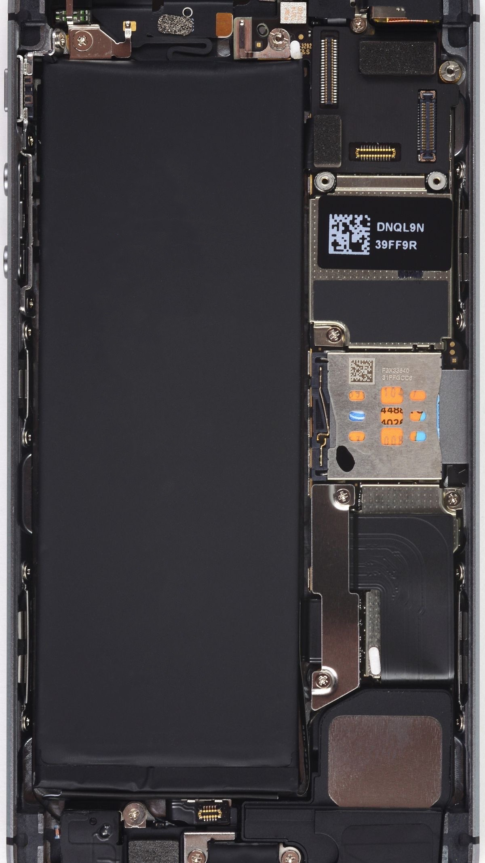

**Advanced Programming**

**Project**



**Done by:**

Abdulaziz Abdullah Bahamid 441016576

Abdulaziz Raad Alamoudi 441016500

**Course: advanced programming**

**Group: 1**

**To begin with, this is a console-based program, source code programmed with JAVA using Netbeans IDE 12.5, connected to MySQL 8.0 Database using JDBC Driver Manager.**

**The main idea of the project is to implement a program that takes a student info and store it in the database then offers to retrieve it.**

**We started by creating the database and created a table in it to store the data**

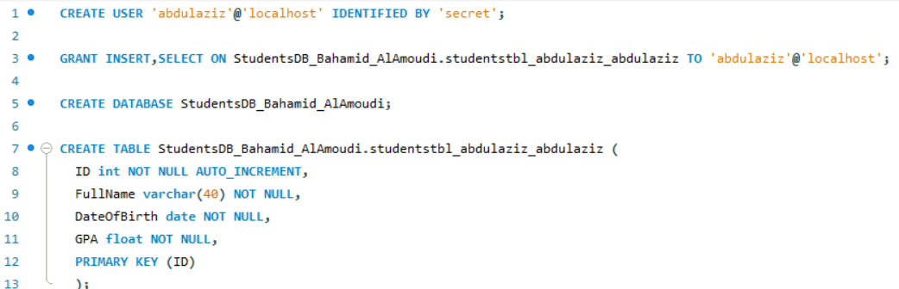

**The program consists of four options displayed when it is first run, it welcomes the user with a simple message followed by the menu**

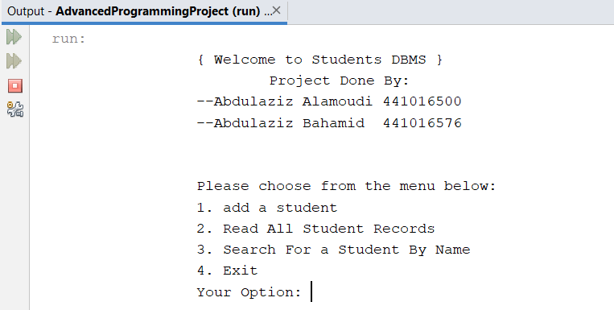

**We implemented it by printing welcome message in the beginning**

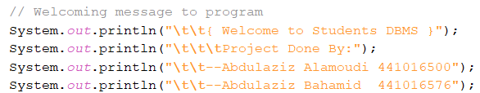

**followed by do-while loop that invokes printMenu method followed by switch-case for the user inputs**

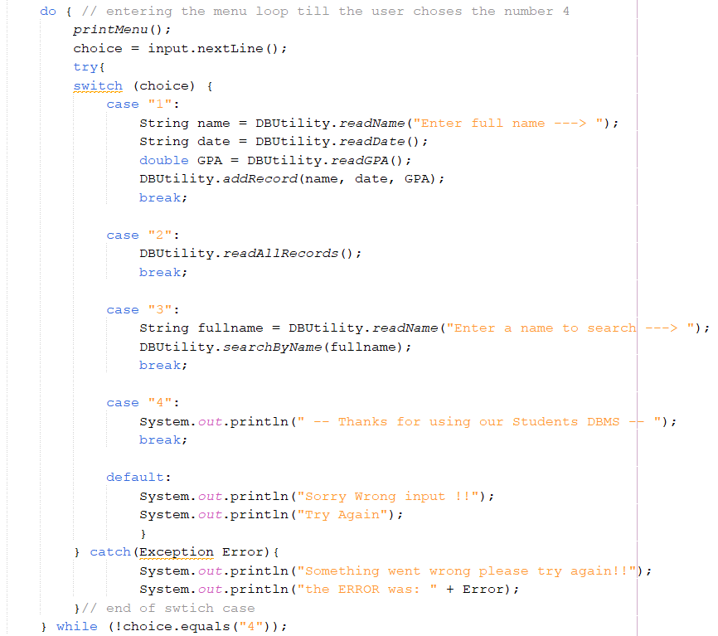

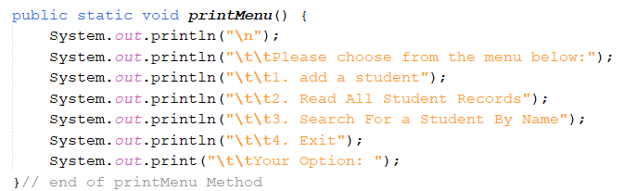

**The first important step in implementing each option is to get connection to the data base, and that is only possible if the correct driver is installed correctly, To do that we install it then put it among the libraries of our package**

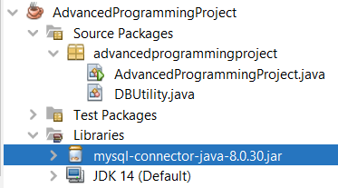

**Then we test connectivity using the created user**

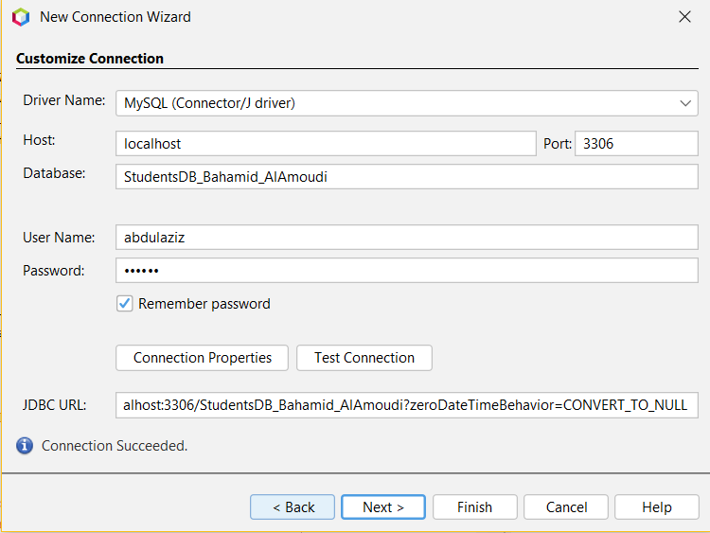

**After the setup has been completed, we created a utility class called DBUtility and it stores static methods that concerned with dealing with the user input and the database queries.**

**Each time we need to query the database we need a connection object so we made the getConnection method in the DBUtility:** 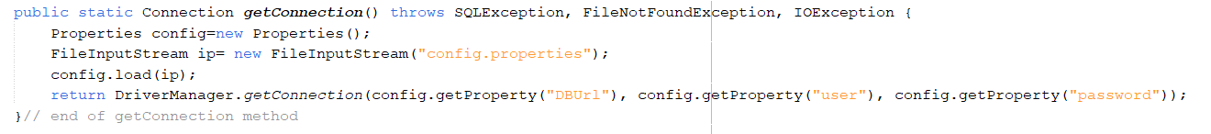

**The method will grab a configuration file that holds the info we need to connect to the database like database URL and the user with its password here what the file looks like**

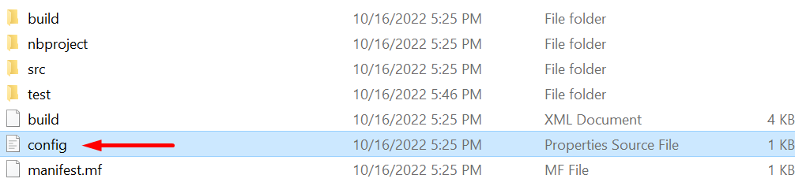

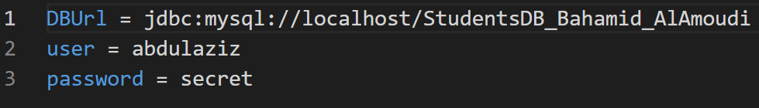

**Now we will discuss what happens each time the user selects an option**

**Option #1 add record:** 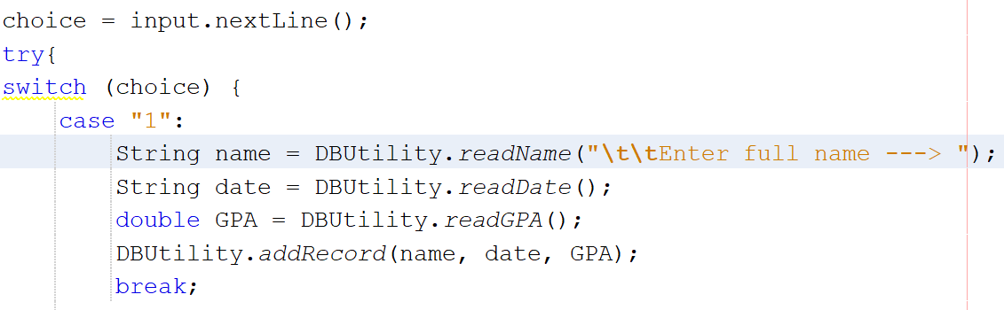

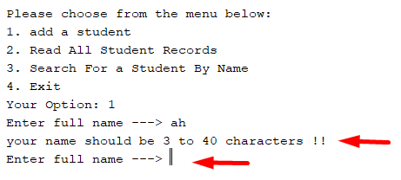**The program will call a method in the DBUtility class called readName it will ask the user to enter a name between 3 characters to 40 and and it will handle the errors like for example the user entered less than 2 characters or more than 40 characters this message will be printed then the program will ask the user to enter a name that complies with our conditions.**

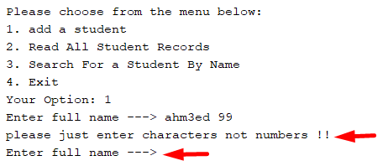**And if the user entered numbers in the name the program will print this message and ask him again to enter a name that complies with our conditions.**

**After the user enters a correct input, the program will continue.**

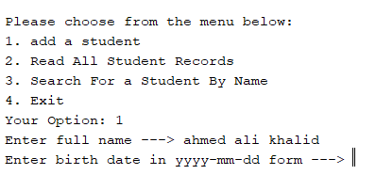

**After that the main method will call another method from DBUtility class called readDate**

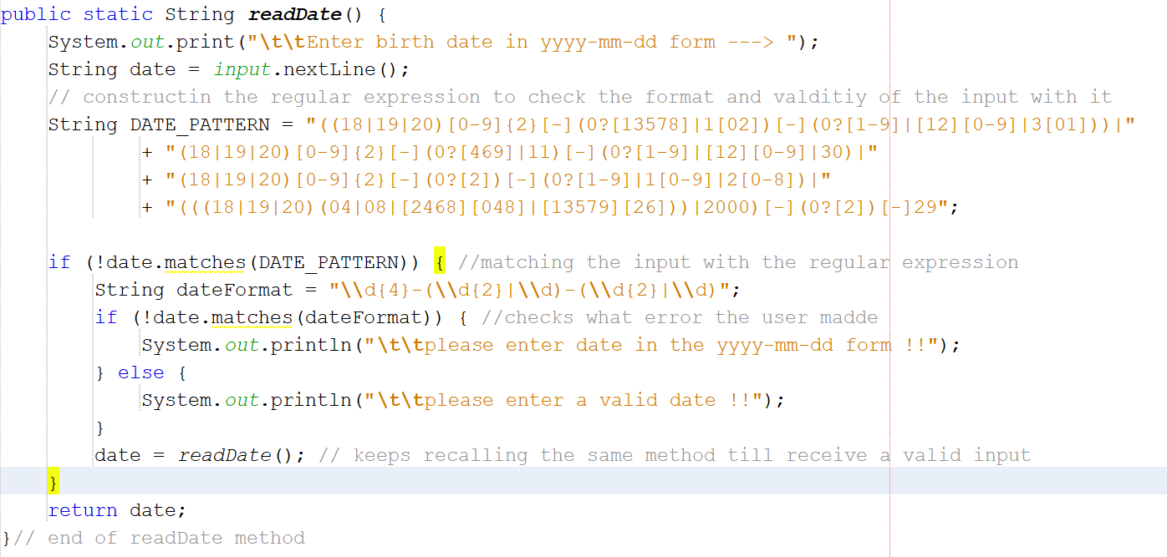

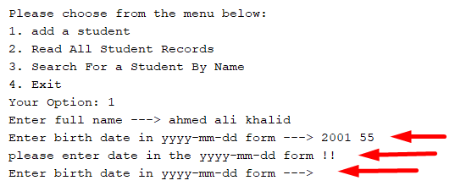**This method will ask the user to enter a date with YYYY-MM-DD format and if the user enters anything other than that the program will print this message and it will ask him again for a correct date format.**

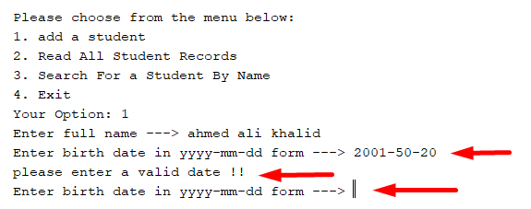

**Also if the user entered a valid format it may be an invalid date like a month number more than 12 here what it is will like like**

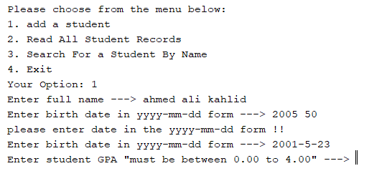

**Abd if the user entered a correct date format and it was valid the porgam will continue.**

**Last but not least the main method will call another method from the DBUtility called readGPA**

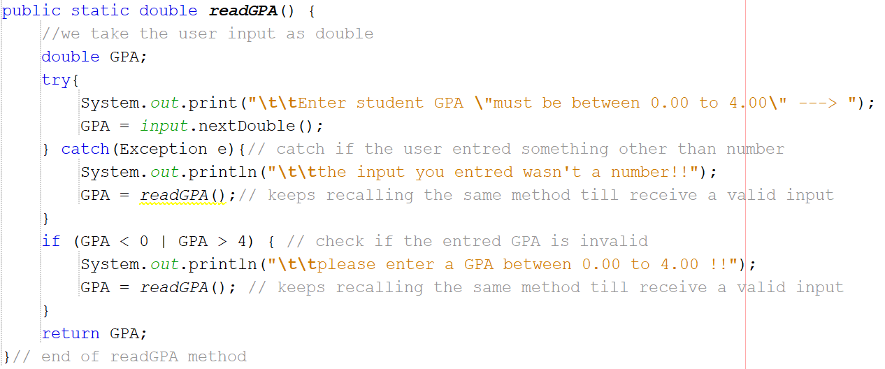

**Finally we will pass all the input from the user to a method in the DBUtility class called addRercord that will create a new connection to the database then it will run a premade query using the prepare statement object then sets the values in response to the parameters passed, then if the record inserted to the database it will print that.**

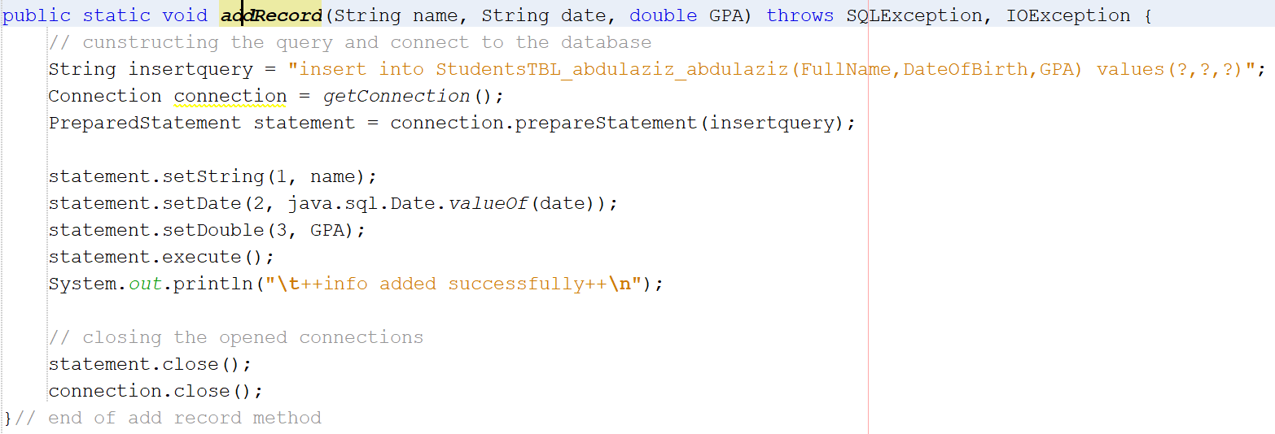

**\*insert a screenshot if added successfully to the database\***

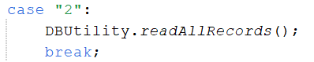

**Option #2 retrieve all records:**

**The program will call a method in the DBUtility class called readAllRecords it does not need any input from the user it simply print the all students records in the database.**

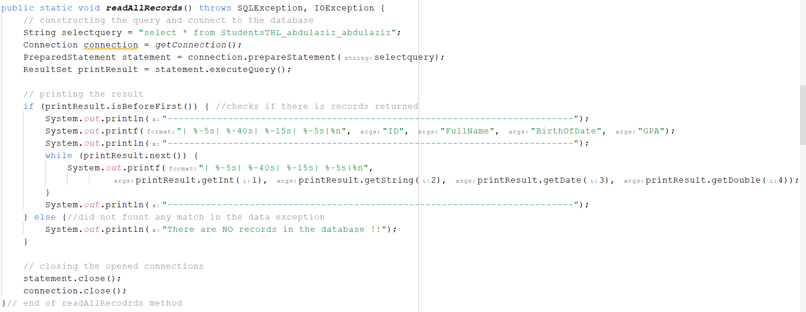

**And this how the output will look like if there are already inserted records in the database:**

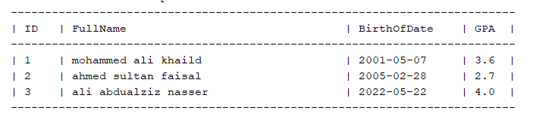**And here the output if there are no records in the database:**



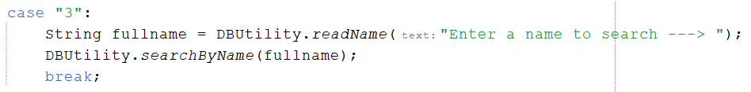**Option #3 search by name:**

**The program will call a two methods from the DBUtility class readName like in the first option to ask the user to enter a name to search for in the database then pass that name to the searchByName method:**

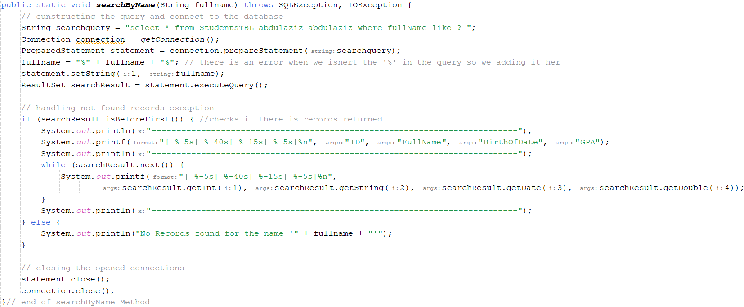

**This method run query in database with name entered from the user and search for any record that has the name within it then print every record that matched the criteria.** 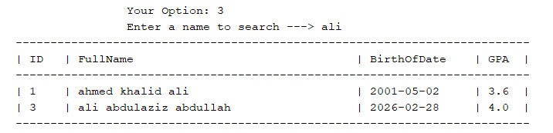

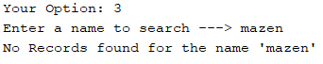**if there were no matches the program will display a message for that.**

**Option #3 and the last one "EXIT":**